**Morgan State University**

Quantum Laboratory Sequence

Quantum Lab #2: Nonclassical Correlations

**Reference: Textbook Section**

**Motivation**

[For Eric]

**Background**

As we have learned, two or more "qubits" can be entangled, such that they cannot be individually separated in quantum state representations. There are 4 maximally entangled 2-qubit states that are called Bell states, given by

(1)

(2)

(3)

(4)

Here, H means horizontal polarization and V means vertical polarization. Let's assume the polarizer for Signal 1 (see Fig. 1) is set at an angle *a* relative to horizontal. Put into Dirac notation, we could define this Measurement #1 as

(5)

Notice when *a* = 0, the measurement is of the state only. Similarly, we can define the measurement of qubit #2 with a polarizer at an angle *b* relative to horizontal as

(6)

To determine the remaining state for qubit #2 upon the measurement of qubit #1, we can "bracket" Eq. (5) with one of the entangled qubit states represented by Eqs. (1)-(4). For example, assuming the entangled state is bracketed by the Measurement #1 represented by Eq. (5), we get

(7)

This is the remaining wave function that is applicable only to qubit #2, since qubit #1 has been measured. Now we need the probability that qubit #2 will be measured at angle *b* after qubit #1 has been measured at angle *a*. To accomplish this, we bracket Eq. (7) with the measurement of qubit #2 via Eq. (6), which results in

(8)

To be a *probability*, we need to take the square of this bracketed result, such that

(9)

Therefore, we know the probability that we will detect both qubit #1 at angle *a* and qubit #2 at angle *b* for an entangled two-qubit state , which per Eq. (9) apparently can be a maximum of 50%.

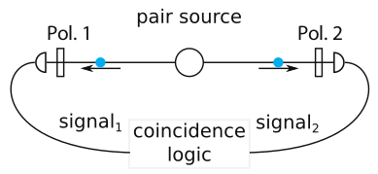**Figure 1.** A photon pair source producing photons with certain polarizations can be measured with separate detectors that have defined polarizer orientations in front. The coincidence instrumentation counts how many photons arrive simultaneously for a given setup.

Now, let's assume we do not have an entangled state. For example, assume we create two qubits that happen to have horizontal polarization, but are not entangled. This state can be represented as

(10)

If we measure the two qubits again using Eqs. (5) and (6), we obtain

(11)

Note that this probability can be from 0 to 1, which exemplifies that a non-entangled pure state of two qubits with the same polarization can potentially be jointly detected with 100% probability. We would obtain a similar result for another non-entangled state such as(i.e. the first photon is horizontally polarized; and the second photon is vertically polarized).

Coincidence probabilities can be calculated for all of the maximally entangled states represented by Eqs. (1)-(4) and the pure states like and , as summarized in Table 1.

**Table 1.** Coincidence probabilities for various entangled and non-entangled quantum states.

|  |  |
| --- | --- |
| **Quantum State** | **Coincidence Probability *P*ab** |
|  |  |
|  |  |
|  |  |
|  |  |
|  |  |
|  |  |
|  |  |
|  |  |

The coincidence probabilities for maximally entangled states,, and non-entangled pure states and , are shown in Fig. 2. Note the very different shapes of the coincidence probability curves for these states.

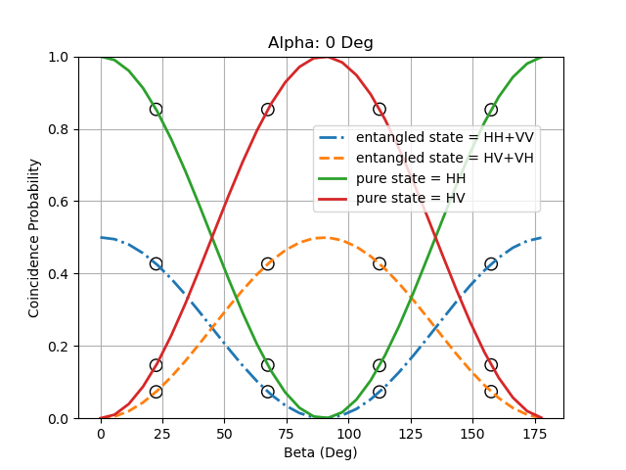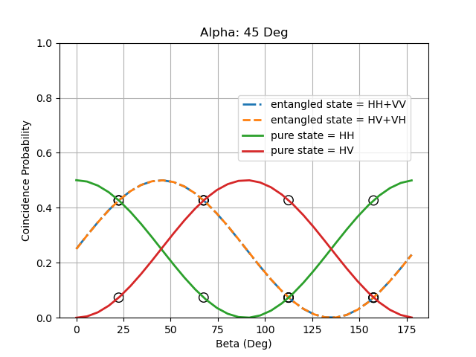**Figure 2.** (Left) Coincidence probabilities for entangled and non-entangled (pure) states when α = 0º; (Right) Coincidence probabilities for entangled and non-entangled (pure) states when α' = 45º. The markers show the coincidence probabilities for the ideal β = 22.5º, 67.5°, 112.5° and 157.5°.

As we did in Lab #1, a useful measure of entanglement is the factor *S* used to test the Bell Inequality. As a reminder,

(12)

where is the *normalized* correlation. The maximum value of *S* from Eq. (11) occurs when and , which is achieved for α = 0º, α' = 45°, β = 22.5º and β' = 67.5°. These angles and corresponding coincidence probabilities are shown as markers in Fig. 2.

**Experimental**

The primary goal of this experiment is to measure the probabilities of detecting two qubits that may, or may not, be in an entangled state, for different measurement settings (i.e. varying *a* and *b*).

One way to consider whether a quantum system is in a certain state is to observe the coincidence probability curves, such as Fig. 2, and in some sense visually determine the quantum state that produces such behavior.

Another way is to conduct a Bell test as we did in Lab #1 to calculate the *S* value. Per Eq. (12), we need the *normalized* correlationsfor four different angle combinations, namely α = 0º, α' = 45°, β = 22.5º and β' = 67.5°. Our setup provides coincidence counts due to a pulsed source of entangled photons traveling along different equal-length paths, and being absorbed by respective Avalanche Photodiodes (APDs). The normalized correlations are given by

(13)

However, as collated in Table 1, we have calculated the *probabilities* of detection, but the coincidence counts are directly proportional to these probabilities. Therefore, we can still use coincidence counts to calculate the correlations for quantum states in Table 1. With these values of for four different angle combinations, we again can calculate the Bell Inequality *S* value through Eqs. (12) and (13).

**Lab Setup**

Connect the fiber optics to the Avalanche Photodiode (APD) ports #1 and #2 of the quED Control & Readout (quCR) unit as shown in Figure 2.

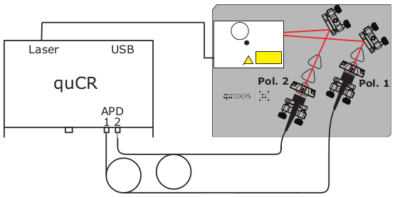**Figure 2.** Setup for the Non-Classical Correlations experiment

1. Check the alignment and entanglement of the source
   1. Go to Settings->Visibility PiP (Upper left menu of H-H, V-V, V-H etc should appear)
   2. Press the graph icon on right middle of screen
   3. Press V-V on upper left menu. Note high green coincidence counts
   4. Press H-V and note dramatic drop in coincidence counts
   5. If you do not see this large change in coincident counts, please see the TA
2. Verify the two polarizers are in the intended slots as shown in Fig. 2. Look at the polarizers to find the white lines. For Horizontal polarization, you should see a horizontal white line.

**Measurements and Calculations**

1. On the quCR main instrument, press the quApp icon until the "Correlations Curve" page is shown.
2. In the Correlation Curves tab, set the measurement time to 2,000 msec, and the angle range from 0 to 360 degrees. The number of steps can be set to 144. By pressing Start, the measurements will be carried out automatically.
3. Make sure the markers are set to be observable for the a, a', b, and b' combinations.
4. You should see screens on the quCR display that look similar to Figs. 3 and 4. By visually inspecting the quCR screen of the output, fill out the lab worksheet of Table 2 for each of the 16 measurements by writing in the observed coincident counts.
5. Using the worksheet of coincident counts in Table 2, calculate each normalized correlation using Eq. (13) and write the answer in the corresponding cell in the last column of Table 2.

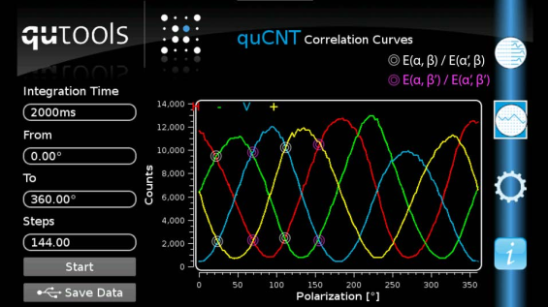**Figure 3.** Correlation curves as measured with the quCR software for the entangled state. The values for the CHSH inequality are marked.

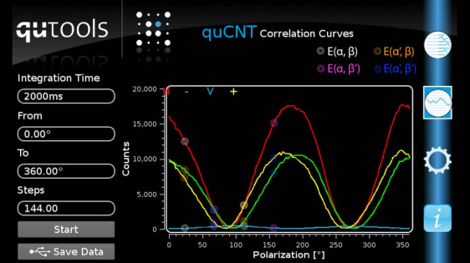**Figure 4.** Correlation curves as measured with the quCR software for the product state. The values for the CHSH inequality are marked.

**Discussion**

By comparing the ideal theoretical probability curves of Fig. 2 to the experimentally determined curves shown in the quCR display (examples shown in Figs 3 and 4), can you visually identify thestate? Are there other states from Table 1 visible in the quCR display?

Calculate Bell's inequality using Eq. (12) for the state. Is it > 2?

Calculate Bell's inequality using Eq. (12) for the state. Is it < 2?

As a computer scientist, you could program the calculation of Bell's *S* factor (Eq. 13) using count data as completed in Table 2, but how might you consider using the count curves in a computer program to diagnose entanglement?

**Table 2.** Coincident count worksheet to fill out for each polarization setting.

|  |  |  |  |  |
| --- | --- | --- | --- | --- |
| **Polarization Angle 1** | **Polarization Angle 2** | **Counts** |  |  |
| α = 0º | β = 22.5º |  | __________ | __________ |
| α = 0º | β⟂ = 112.5º |  | __________ |
| α⟂ = 90º | β = 22.5º |  | __________ |
| α⟂ = 90º | β⟂ = 112.5º |  | __________ |
| α' = 45º | β = 22.5º |  | __________ | __________ |
| α' = 45º | β⟂ = 112.5º |  | __________ |
| α'⟂ = 135º | β = 22.5º |  | __________ |
| α'⟂ = 135º | β⟂ = 112.5º |  | __________ |
| α = 0º | β' = 67.5º |  | __________ | __________ |
| α = 0º | β'⟂ = 157.5º |  | __________ |
| α⟂ = 90º | β' = 67.5º |  | __________ |
| α⟂ = 90º | β'⟂ = 157.5º |  | __________ |
| α' = 45º | β' = 67.5º |  | __________ | __________ |
| α' = 45º | β'⟂ = 157.5º |  | __________ |
| α'⟂ = 135º | β' = 67.5º |  | __________ |
| α'⟂ = 135º | β'⟂ = 157.5º |  | __________ |